- Identify the axis of symmetry and vertex:  $$y=x^{2}+4x-3$$  AOS: _______________ Vertex: _____________  Is the vertex a minimum or maximum? ________  What is the value of the discriminant? _________  How many roots does it have? _______________  What are the roots? _______________________ | - Graph the following function:  $$y= x^{2}-8x+12$$  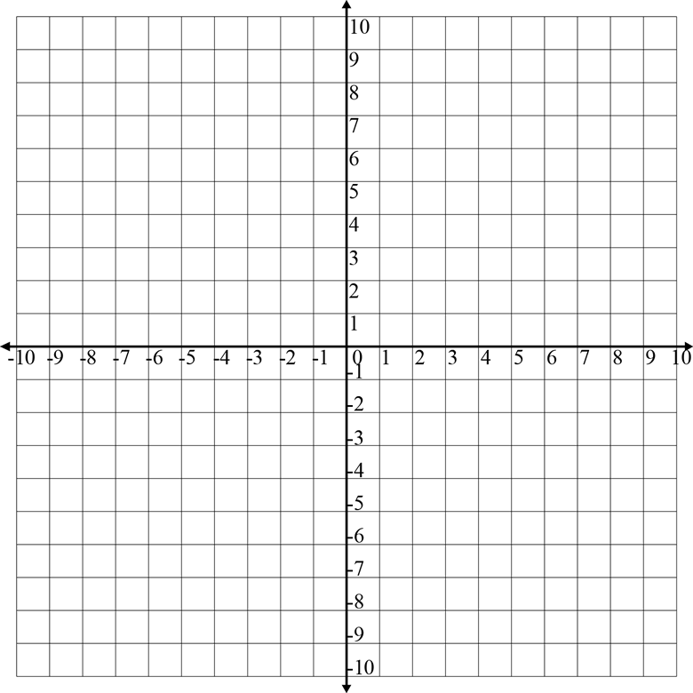
- A model rocket is launched with a velocity of 64 feet per second. The equation $h=-16t^{2}+64t$ gives the height of the rocket t seconds after it is launched.

Graph the equation:

What is the highest the rocket will reach?

