Name: ____________________________________________ Date: _____________________ Period :_________
Fill in each missing small box with the correct information about the equation being represented by each big box. Each big box represents a different equation. Highlight the slope in each representation in pink, and the y-intercept in yellow.
Equation  Point-Slope Form:  Slope-Intercept Form:  Standard Form: | Graph  1
Table | Information  Slope: ________________  Y-Intercept: ___________  Point on the Graph: (5, 8)

Equation  Point-Slope Form:  Slope-Intercept Form:  Standard Form: | Graph  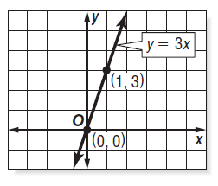  3
Table | Information  Slope: ________________  Y-Intercept: ___________  Point on the Graph: ( , )

Equation  Point-Slope Form:  Slope-Intercept Form:  $$y=3x-1$$  Standard Form: | Graph  2
Table | Information  Slope: ________________  Y-Intercept: ___________  Point on the Graph: ( , )

Equation  Point-Slope Form:  Slope-Intercept Form:  Standard Form: | Graph  4
Table  x y  2 -3  4 -1  6 1  8 3 | Information  Slope: ________________  Y-Intercept: ___________  Point on the Graph: ( , )

