Factor all Polynomials:
Part A
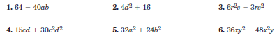

Part B
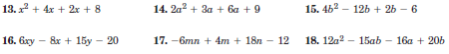

Part C
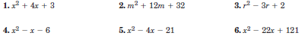

Part D

