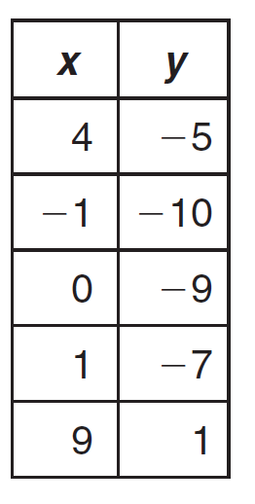
Represent the relation as a mapping, as ordered pairs, and as a graph.
#1

What is the domain?
What is the range?
Is this a function? Why or why not?
#2
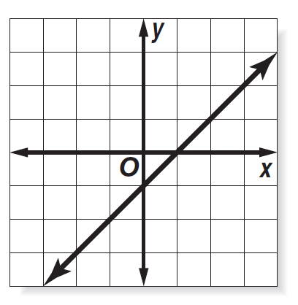
What is the domain?
What is the range?
If f(t) = 2t³
#3

Find f(4)
Find 3[f(p)]
Find 2[f(x+1)]
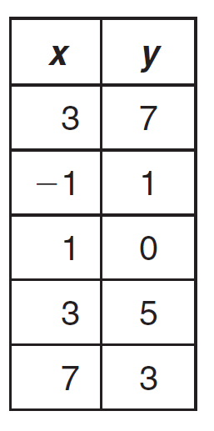
Represent the table as a graph:
#4

Is it a function? Why or why not?
The graph below represents the altitude of a group of hikers. Describe what is happening in the graph.
#5

*Make sure you are specific about every point and change in slope!*
#6+
Draw a graph that explains the months in the year compared with the average temperature. Annotate your graph.

Is the following an arithmetic sequence?
#7
-40, -32, -24, -16
If so, find the common difference and the next three terms in the sequence.
#8
Consider the arithmetic sequence
5, 17, 29, 41
Find the 51st term in this sequence.

